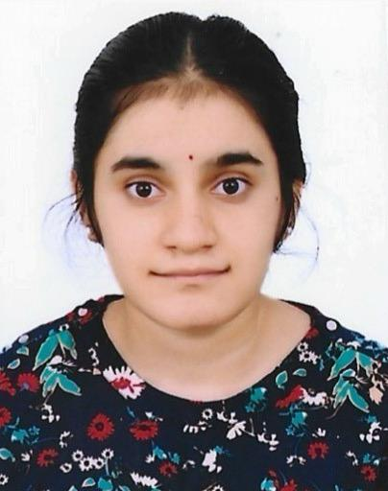 MALLADI PHANI HARI SRIYA
mpsriya@gmail.com | linkedin.com/in/sriya-malladi-40797432a
Nallagandla, Hyderabad, Telangana,500019, India | 8106567785

Profile
To place myself in an organisation where I can be innovative and attain a challenging position by exercising my interpersonal and professional skills to the fullest for the growth of the organisation and mine as well. Dedicated and enthusiastic job seeker with exceptional organizational skills, seeking an entry-level position.

Education

G. Narayanamma Institute of Technology and Science
B. tech -Electronics and Communication Engineering 2022 - 2026
CGPA -7.1
Trinity Junior College
MPC 2020 - 2022
CGPA -9.43
SRICHAITANYA TECHNO SCHOOL 2019 - 2020
SSC
CGPA-10
Skills

- Time Management
- Positive Attitude
- Leadership Qualities
- Team Work
- Problem Solving
- Computer Skills

Technical Skills
- Basic Python, C Programming, C++, DBMS, JAVA, MATLAB

Projects
Worked on Bi-directional Visitor Counter Apr 2024-Aug 2024

Areas of Interest

- Technical skills in Digital Electronics
- Signal Processing

